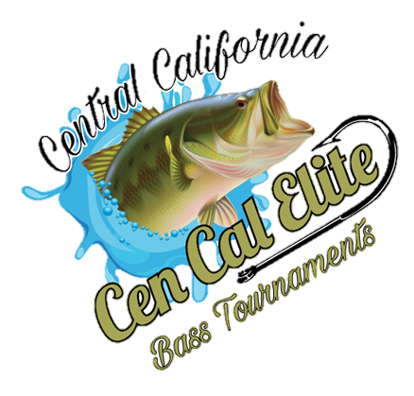
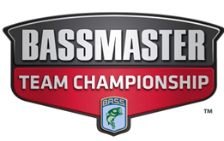
2022
Open Tournament
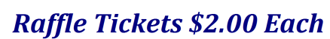
Sat, April 30, 2022
pine Flat Lake
Island Park Launch Ramp
Burger w/ the fixings, chili beans, chips, & drink, $15.00 Per person Due at Registration
From Safe Light – 3:00 PM
Registration Begins @ 4:30 AM
Teams (2 Person) or Singles
Some of the stuff up for Raffle:
Yeti Cooler, Dobyns Rods, Trailer Tires Certificate, Lower Unit Certificate, Boat Oil, Casino Baskets.
5 Fish Limit Per Boat
$250.00 including all options

All prizes, awards paid out at lake
For more information or questions please contact David Coy 559-280-8884
______________________________________________________________________________________________
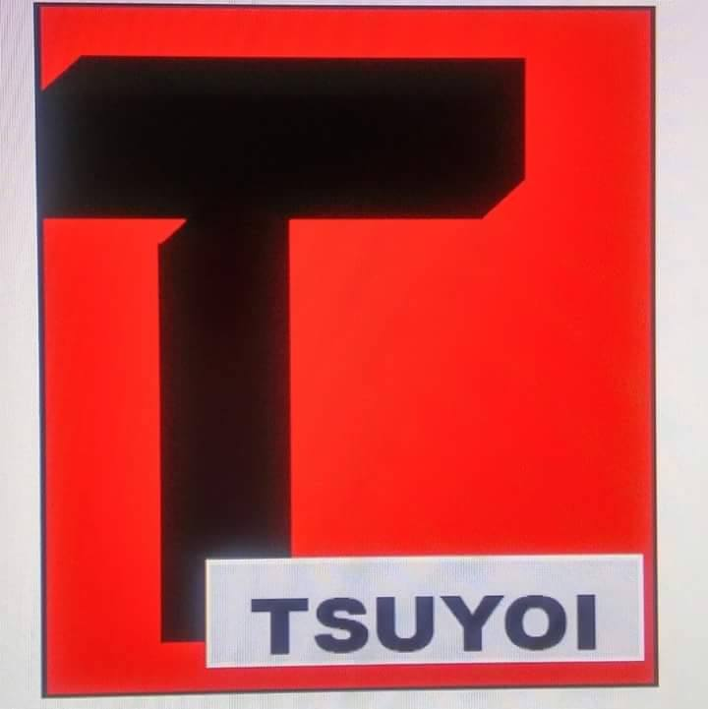
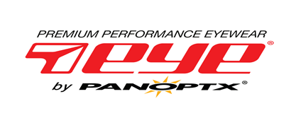
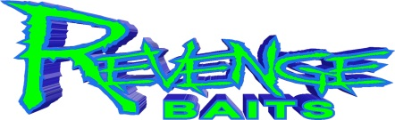
Thank you to all our sponsors
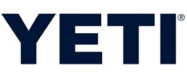
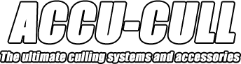
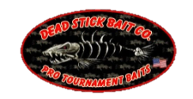
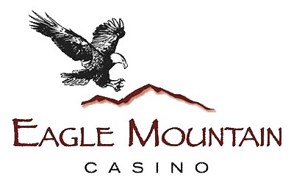
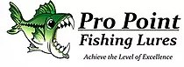
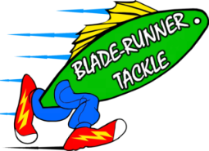
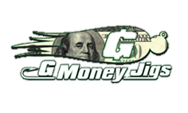
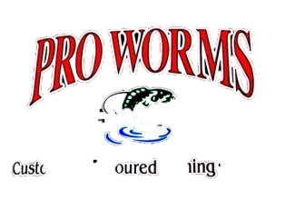
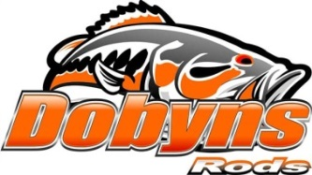
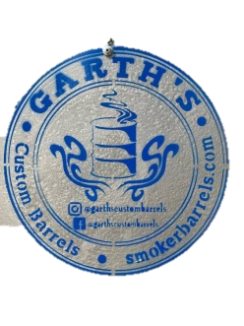
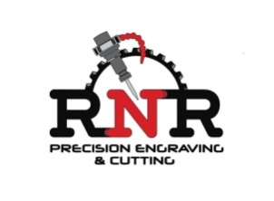

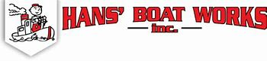
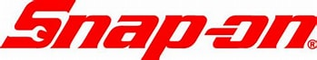
Craig Gong 559-903-2235 Bill Simmons Tires

